An artificial intelligence (AI) agent is a software program that can interact with its environment, collect data and use that data to perform self-directed tasks that meet predetermined goals. Humans set goals, but an AI agent independently chooses the best actions it needs to perform to achieve those goals.
For example, consider a customer support AI agent that wants to resolve customer queries. The agent will automatically ask the customer different questions, look up information in internal documents and respond with a solution. Based on the customer responses, it determines if it can resolve the query itself or pass it on to a human.

Key Features of AI Agents
- Autonomous: Act without constant human input and decide next steps from past data like a bookstore bot flags missing invoices.
- Goal-driven: Optimize for defined objectives like a logistics AI balancing speed, cost and fuel use.
- Perceptive: Gather info from sensors, inputs or APIs like a cybersecurity agent tracking new threats.
- Adaptable: Adjust strategies when situations change.
- Collaborative: Work with humans or other agents toward shared goals like healthcare agents coordinating with patients and doctor.

How do AI Agents Work?
1. Persona: Each agent is given a clearly defined role, personality and communication style along with specific instructions and descriptions of the tools it can use. A well-crafted persona ensures the agent behaves consistently and appropriately for its role, while also evolving as it gains experience and engages with users or other systems.
2. Memory: Agents typically have multiple types of memory:
- Short-term memory for the current interaction
- Long-term memory for storing historical data and conversations
- Episodic memory for recalling specific past events
- Consensus memory for sharing knowledge among multiple agents
Memory enables an agent to keep context, learn from experience and adapt its behaviour over time.
3. Tools: These are functions or external resources the agent can use to access information, process data, control devices or connect with other systems. Tools may involve physical interfaces, graphical UIs or programmatic APIs. Agents also learn how and when to use these tools effectively, based on their capabilities and context.
4. Model: Agents use large language model (LLM) which serves as the agent’s “brain”. The LLM interprets instructions, reasons about solutions, generates language and orchestrates other components including memory retrieval and tools to use to carry out tasks.

Architecture of AI Agents
There are four main components in an AI agent’s architecture:
- Profiling Module: This module helps the agent understand its role and purpose. It gathers information from the environment to form perceptions. For example: A self-driving car uses sensors and cameras to detect obstacles.
- Memory Module: The memory module enables the agent to store and retrieve past experiences. This helps the agent learn from prior actions and improve over time. For example: A chatbot remembers past conversations to give better responses.
- Planning Module: This module is responsible for decision-making. It evaluates situations, weighs alternatives and selects the most effective course of action. For example: A chess-playing AI plans its moves based on future possibilities.
- Action Module: The action module executes the decisions made by the planning module in the real world. It translates decisions into real-world actions. For example: A robot vacuum moves to clean a designated area after detecting dirt.

AI Agent Classification
An agent is a system designed to perceive its environment, make decisions and take actions to achieve specific goals. Agents operate autonomously, without direct human control and can be classified based on their behavior, environment and number of interacting agents.
- Reactive Agents: Respond to immediate environmental stimuli without foresight or planning.
- Proactive Agents: Anticipate future states and plan actions to achieve long-term goals.
- Single-Agent Systems: One agent solves a problem independently.
- Multi-Agent Systems: Multiple agents interact, coordinate or compete to achieve goals; may be homogeneous (similar roles) or heterogeneous (diverse roles).
- Rational Agents: Choose actions to maximize expected outcomes using both current and historical information.

Types of Agents

1. Simple Reflex Agents
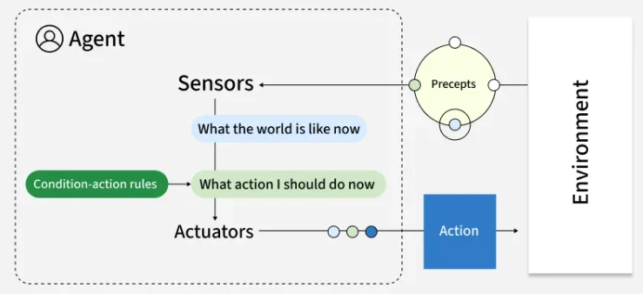
Simple reflex agents act based solely on current perceptions using condition-action rules. These agents respond directly to stimuli without considering past experiences or potential future states. They operate on basic "if-then" logic: if a specific condition is detected, execute a corresponding action.
Key Features:
- No memory of past states
- No model of how the world works
- Purely reactive behavior
- Function best in fully observable environments
For Example, Traffic light control systems that change signals based on fixed timing.

2. Model-Based Reflex Agents
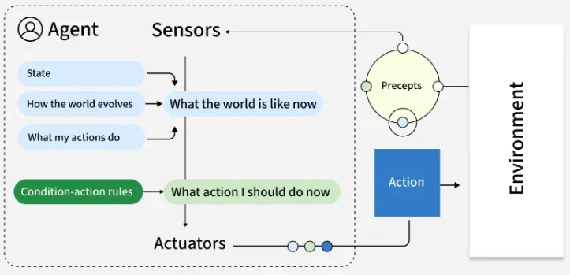
Model-based reflex agents maintain an internal representation of the world, allowing them to track aspects of the environment they cannot directly observe. This internal model helps them make more informed decisions by considering how the world evolves and how their actions affect it.
Key Features:
- Track the world's state over time
- Infer unobserved aspects of current states
- Function effectively in partially observable environments
- Still primarily reactive, but with contextual awareness
For example, Robot vacuum cleaners that map rooms and tracks cleaned areas.

3. Goal-Based Agents
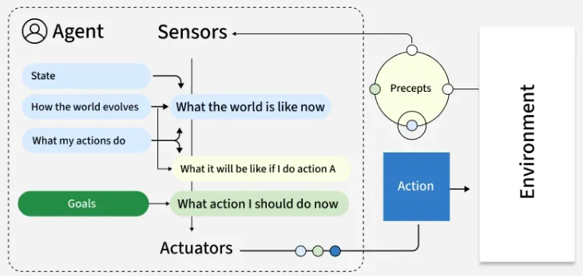
Goal-based agents plan their actions with a specific objective in mind. Unlike reflex agents that respond to immediate stimuli, goal-based agents evaluate how different action sequences might lead toward their defined goal, selecting the path that appears most promising.
Key Features:
- Employ search and planning mechanisms
- Evaluate actions based on their contribution toward goal achievement
- Consider future states and outcomes
- May explore multiple possible routes to a goal
For example, Logistics routing agents that find optimal delivery routes based on factors like distance and time. They continually adjust to reach the most efficient route.

4. Utility-Based Agents
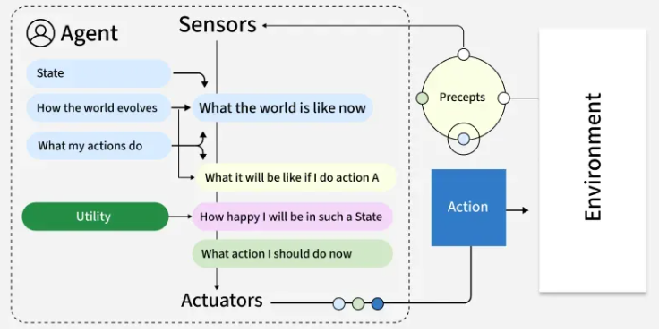
Utility-based agents extend goal-based thinking by evaluating actions based on how well they maximize a utility function—essentially a measure of "happiness" or "satisfaction." This approach allows them to make nuanced trade-offs between competing goals or uncertain outcomes.
Key Features:
- Balance multiple, sometimes conflicting objectives
- Handle probabilistic and uncertain environments
- Evaluate actions based on expected utility
- Make rational decisions under constraints
For example, Financial portfolio management agents that evaluate investments based on factors like risk, return and diversification operate by choosing options that provide the most value.

5. Learning Agents
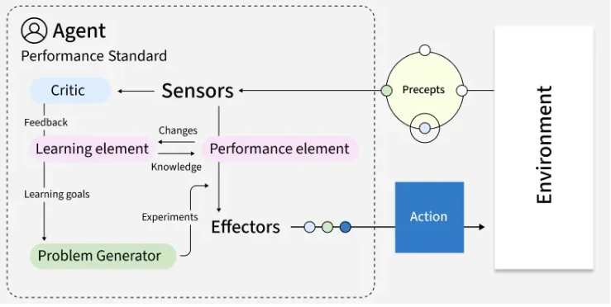
Learning agents improve their performance over time based on experience. They modify their behavior by observing the consequences of their actions, adjusting their internal models and decision-making approaches to achieve better outcomes in future interactions.
Key Features:
- Adapt to changing environments
- Improve performance with experience
- Contain both a performance element and a learning element
- Generate new knowledge rather than simply applying existing rules
For example, Customer service chatbots can improve response accuracy over time by learning from previous interactions and adapting to user needs.

6. Multi-Agent Systems (MAS)
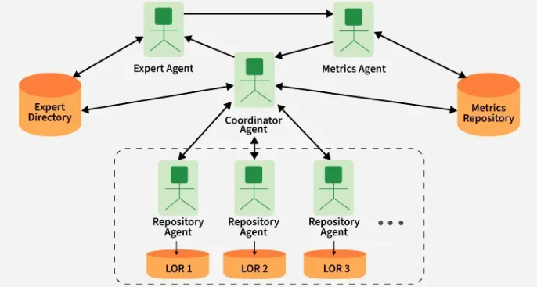
Multi-Agent System Working
Multi-agent systems consist of multiple autonomous agents that interact with each other within an environment. These agents may cooperate toward common goals, compete for resources or exhibit a mix of cooperative and competitive behaviors. Types of multi-agent systems:
- Cooperative MAS: Agents work together toward shared objectives.
- Competitive MAS: Agents pursue individual goals that may conflict.
- Mixed MAS: Agents cooperate in some scenarios and compete in others.
Key Features:
- Agents act independently and control their own state.
- Agents align, collaborate or compete to reach goals.
- The system remains resilient if individual agents fail.
- Decisions are distributed; there’s no single controller.
For example, a warehouse robot might use:
- Model-based reflexes for navigation
- Goal-based planning for task sequencing
- Utility-based decision-making for prioritizing tasks
- Learning capabilities for route optimization

7. Hierarchical agents
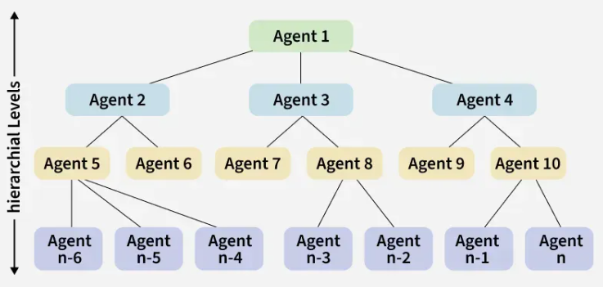
Hierarchical agents organize decision-making across multiple levels, with high-level agents making strategic decisions and delegating specific tasks to lower-level agents. This structure mirrors many human organizations and allows for managing problems at appropriate levels of abstraction.
Key Features:
- Division of responsibilities across multiple levels
- Abstract decision-making at higher levels
- Detailed execution at lower levels
- Simplified information flow (higher levels receive summarized data)
For example, Drone delivery systems in which fleet management is done at top level and individual navigation at lower level.

Use Cases of AI Agents
Agents are used in a wide range of applications in artificial intelligence, including:
- Robotics: Agents can be used to control robots and automate tasks in manufacturing, transportation and other industries.
- Smart homes and buildings: They can be used to control heating, lighting and other systems in smart homes and buildings, optimizing energy use and improving comfort.
- Healthcare: They can be used to monitor patients, provide personalized treatment plans and optimize healthcare resource allocation.
- Finance: They can be used for automated trading, fraud detection and risk management in the financial industry.
- Games: They can be used to create intelligent opponents in games and simulations, providing a more challenging and realistic experience for players.

Benefits of AI Agents
- Fast and efficient operations.
- Adapt and learn from experience.
- Scalable for large or complex problems.
- Operate autonomously with minimal human input.
- Consistent, reliable task performance.

Limitations:
- Struggle with complex or unpredictable environments.
- High computational needs for learning and planning.
- Communication issues in multi-agent setups.
- Risk of bias or unintended actions.
- Challenges in designing clear goals and utility functions.
AI Agent Architectures examine the complex structures that shape how machines perceive, reason, and act in their environments in the pursuit of autonomous intelligence. This article explores the various structures that shape AI's decision-making capabilities

AI Agent Architecture
An intelligent agent system's basic components and interactions are outlined in an AI agent architecture, which functions as a conceptual design. It offers a methodical framework for creating, putting into practice, and comprehending agents that may independently interact with their surroundings to accomplish predetermined goals. Agent architectures are important because they provide a methodical way to design and evaluate complex AI systems, enabling scientists and engineers to build agents with certain features and functions.
Let's discuss each component of AI Agent architecture in detail:

1. Profiling Module: The Eyes and Ears of the Agent
- The agent is endowed with sensory expertise via the profiling module, it is also known as the perception module. With the help of this module, the agent may collect and analyze information from its environment like how human senses work. It interprets unprocessed sensory data, eliminates superfluous details, and extracts important characteristics that are essential for making decisions. The agent's accurate and thorough grasp of its surroundings is ensured by the profile module, which helps it comprehend visual signals, recognize speech patterns, and sense tactile inputs.
- Imagine a self-driving automobile that has radar, lidar, and camera sensors. Through the processing of data from various sensors, the profile module recognizes barriers, traffic lights, and lane markers, allowing the vehicle to go safely.

2. Memory Module: The Repository of Knowledge
- The memory module is essential for organizing and storing data as it serves as the agent's knowledge base. It allows the agent to remember information, rules, patterns, and events from the past. It functions similarly to the agent's short- and long-term memory. For the agent to make wise judgments, learn from its interactions, and have a sophisticated grasp of its surroundings, this module is crucial.
- To provide timely and correct replies during discussions, a virtual assistant chatbot, for example, uses its memory module to remember client requests, product specs, and commonly asked questions.

3. Planning Module: The Strategist Behind Decisions
- The agent's central decision-making command post for making decisions and acting in a goal-oriented manner is the planning module. This module examines the present situation and determines the best course of action to accomplish the agent's goals, taking into account information from the memory and profiling modules. Using strategies like optimization approaches, search algorithms, or rule-based systems, the planning module figures out the best course of action.
- For instance, a delivery routing agent utilizes the planning module to optimize the most effective routes and timetables for its fleet by taking into account variables like vehicle capacity, traffic patterns, and delivery priority.

4. Action Module: From Plans to Execution
- The choices and plans established by the planning module are implemented by the action module. It converts plans into executable commands and serves as the agent's interface with the outside world. This module operates in conjunction with actuators or output devices, carrying out and overseeing the selected course of action. Feedback from the action module helps the planning module make necessary modifications and fixes.
- When a robotic arm is used in a factory, the action module gets instructions on how to pick up and move things. It then sends signals to the robot's motors to carry out the exact motions required to ensure precision assembly jobs.

5. Learning Strategies: The Engine of Adaptation
- The incorporation of learning strategies—mechanisms that let agents change, become better, and learn new things—is essential to agent architecture. Common methods include supervised learning, unsupervised learning, and reinforcement learning. Reinforcement learning directs agents' behavior toward the best results by providing feedback in the form of incentives or punishments. Labeled examples are necessary for supervised learning in order for the agent to anticipate or act. Conversely, unsupervised learning enables agents to find patterns and connections in data without specific direction.
- By improving the agent's capacity to draw conclusions from the past and adjust to new circumstances, these learning techniques help them improve their performance over time.
This breakdown provides a detailed explanation of each component of the AI agent architecture along with examples illustrating their functionalities and applications.

Conclusion
AI agent architectures offer a organized system for comprehending how smart systems independently perceive, reason, and make decisions in their surroundings. The components talked about - profiling module, memory module, planning module, action module, and learning strategies - all work together to allow agents to engage with their environment, make choices, and adjust as needed. AI agents can reach higher levels of autonomy and intelligence by combining sensory skills, knowledge storage, decision-making abilities, action execution, and learning mechanisms. These structures act as crucial models for creating and assessing intricate AI systems, enabling researchers and engineers to create agents that can effectively complete particular tasks and objectives.

AI agents have become the backbone of complex task automation, decision-making and workflow management across industries. These frameworks help developers and businesses to build intelligent agents that operate autonomously, coordinate tasks and integrate with a wide range of tools and platforms. In this article we will see different AI Agent Frameworks to make our own agents.
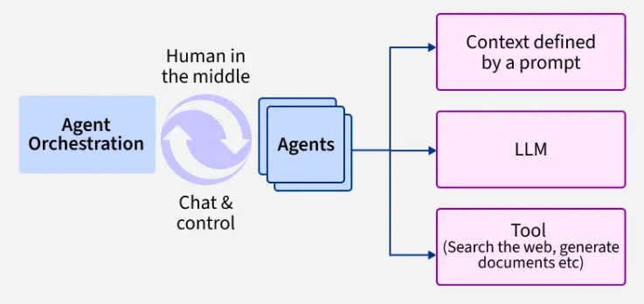

1. LangGraph
LangGraph is designed for building and managing advanced autonomous agents capable of handling independent workflows. Its architecture is inspired by directed acyclic graphs (DAGs) which helps in the execution of complex, branching processes such as starting a chatbot session, continuing the conversation and ending it upon achieving goals.

Features:
- Smaller Workflow Control: Allows developers to design agent flows at small steps, supporting multi-agent, hierarchical and sequential processes.
- Statefulness: Lets agents remember details from past steps so they can pick up where they left off which also makes it easier to trace and fix problems in their workflows.
- Adaptive Retrieval-Augmented Generation (RAG): It supports advanced knowledge-augmented reasoning, letting agents execute adaptive tasks with minimal human input.
- Integration Ready: Easily connects with various LLMs, vector databases, monitoring, debugging and human-in-the-loop controls.
Use Case: Automating support ticket where agent receives input, gathers context and autonomously routes and resolves queries, escalating only when necessary.

Code:
Let see a code example to understand better, the working of code is explained below:
- Installs Langgraph and Langchain packages
- Defines a function using Langchain's GPT-4o-mini LLM to get a motivational quote
- Creates a Langgraph StateGraph with a single node calling the function
- Sets the node as both entry and finish point in the graph
- Compiles and invokes the graph, printing the motivational quote
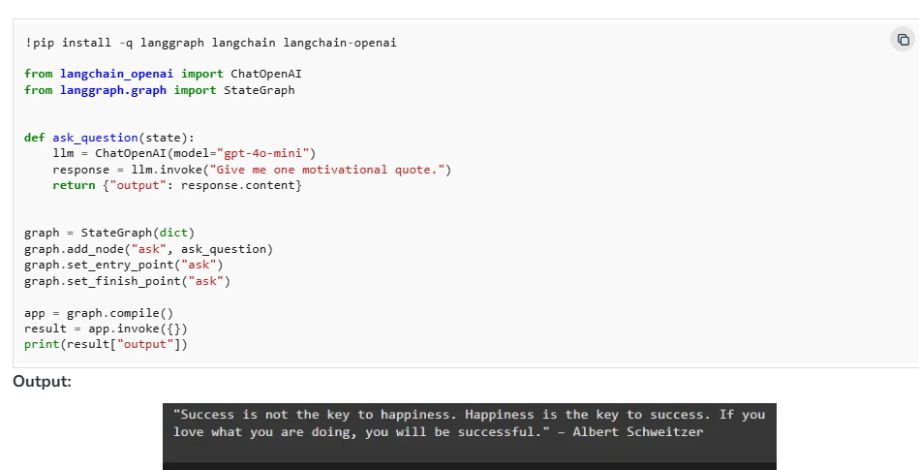

2. AutoGen
AutoGen is a Microsoft-backed multi-agent framework designed for enabling rich, dynamic conversations and automation workflows among AI agents, humans and tools. It emphasizes flexibility, configurability and seamless integration with both large language models (LLMs) and external APIs.

Features:
- Customizable agents: Agents can be defined roles, personas and capabilities.
- Dynamic multi-agent conversations: Agents interact autonomously or with human input for collaboration, debate and problem-solving.
- Tool integration: Connect to APIs, development tools and LLMs for data fetching, code execution and third-party interactions.
- Human oversight: Seamlessly blend automated and manual workflows for complex decisions.
- Conversation history & state: Agents maintain context across interactions for continuity and relevance.
Use Case: AI agents automatically research and draft a technical report with one gathering data, another summarizing and a human reviewer finalizing the content for accuracy and clarity.

Code:
Let's see a code example to understand it better,
- Installs Autogen package from GitHub
- Loads OpenAI API key
- Creates an AssistantAgent configured with GPT-3.5-turbo model and OpenAI key
- Creates a UserProxyAgent with no human input
- Initiates a chat from user to assistant with a starting message and limits turns to 2
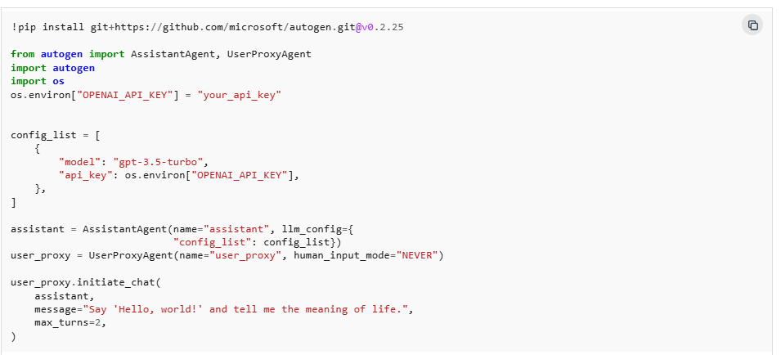
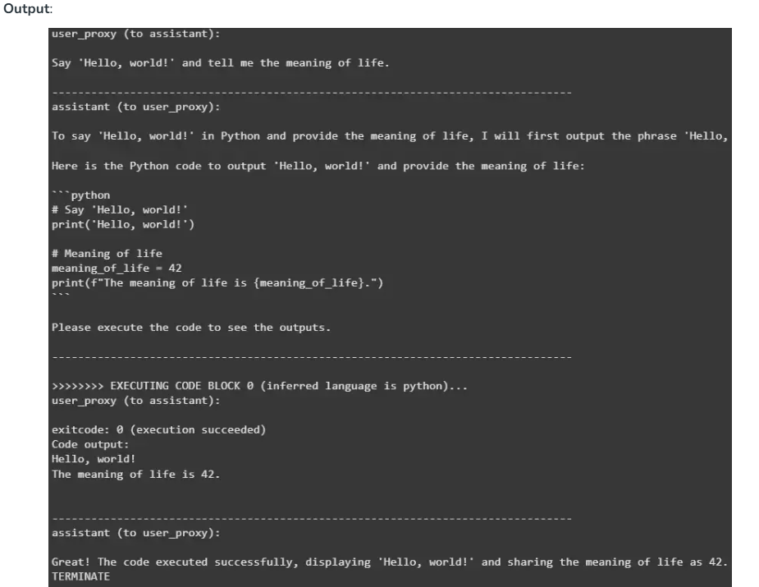

3. CrewAI
CrewAI is an open-source framework that lets developers create and manage teams of specialized AI agents. These agents collaborate, each handling a distinct role, to automate and streamline complex, multi-step workflows such as research, content creation and business processes

Features:
- Specialized Roles: Agents are defined with roles, goals, backstories and tools enabling tailored decision-making.
- Task Kickoff and Coordination: Define a crew of agents, set tasks and let the crew autonomously commence and optimize processes.
- Human-AI and Multi-Agent Collaboration: Ideal for projects where seamless cooperation between autonomous agents and/or humans is required (e.g., research, fraud detection, content creation).
Use Case: Multi-agent systems for generating, vetting and publishing marketing content one agent drafts, another edits, a third handles distribution.

Code:
Let's see a code example to understand better,
- Imports Crew, Agent and Task classes and then checks for OpenAI API key
- Defines two agents: Python Assistant and Philosopher with roles and backstories
- Defines two tasks: Python assistant prints "Hello, world!"; Philosopher shares meaning of life as "42"
- Creates a Crew with the agents and tasks defined
- Starts execution of tasks in parallel and collects results
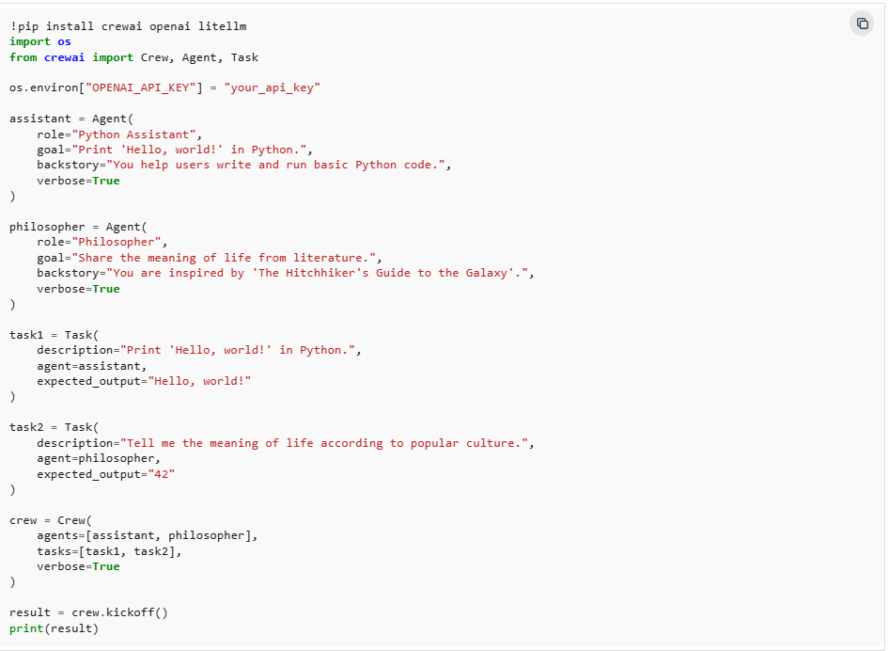
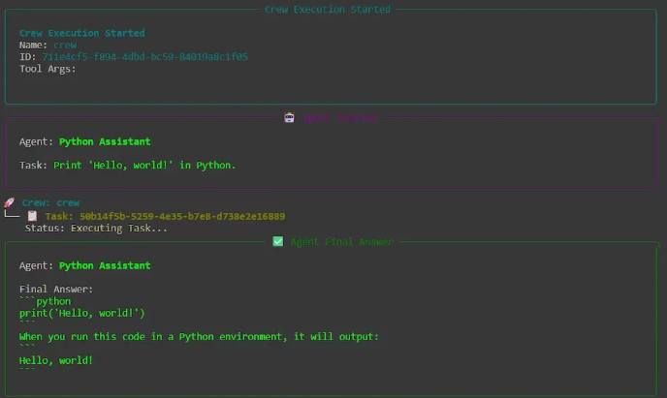
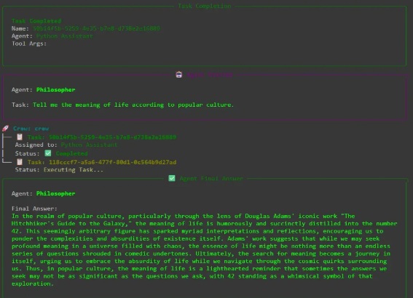
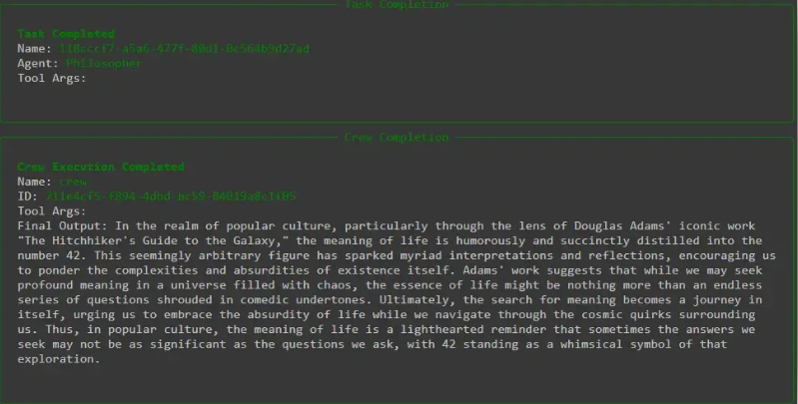

4. Semantic Kernel
Semantic Kernel is an open-source, lightweight Microsoft SDK that lets developers add advanced AI features such as natural language understanding and generation, to applications written in C#, Python or Java. It connects our existing code and business logic to the latest large language models and is built for enterprise-scale, responsible AI adoption.

Features:
- Agent Framework: Build autonomous or semi-autonomous agents that collaborate, process information and trigger actions using LLMs, APIs or human input.
- Orchestration Engine: Seamlessly sequence and coordinate tasks across AI, systems and human reviewers for end-to-end automation.
- Context and Memory: Maintain conversation history and app state across interactions, enabling personalized, multi-turn experiences.
- Human-in-the-Loop: Insert human approval or refinement steps into automated workflows for oversight and exception handling.
Use Case: AI automatically summarizes customer feedback, integrates with business tools and alerts human staff for key issues, all in one workflow.

Code:
Let's see a code example to understand better,
- Installs Semantic Kernel version 1.35.3
- Loads OpenAI API key from Colab secrets
- Defines a wrap_text function to word-wrap output at 70 characters
- Asynchronously creates a Kernel instance and OpenAIChatCompletion client with GPT-3.5-turbo model
- Sets the Kernel’s private chat service to the client
- Calls chat_complete_async with a prompt to write a short poem about Semantic Kernel
- Prints the word-wrapped result
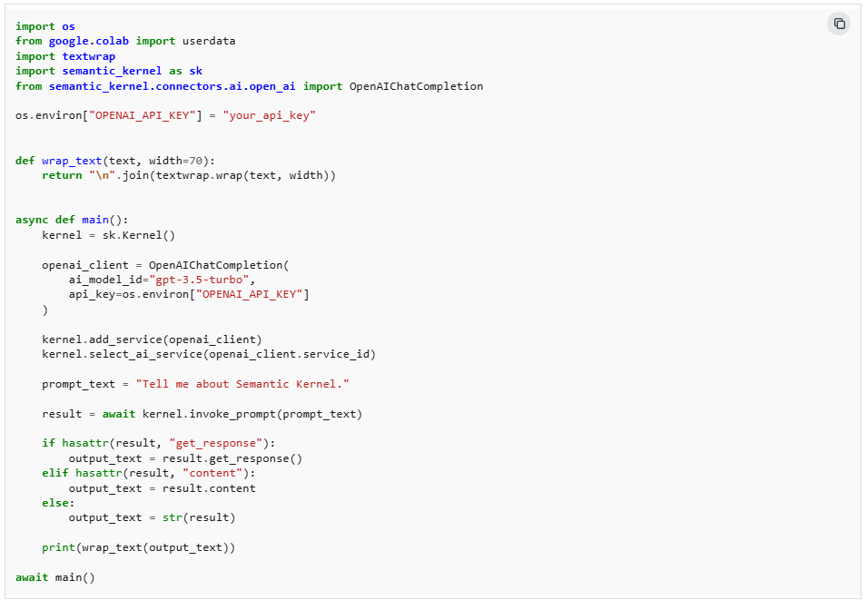
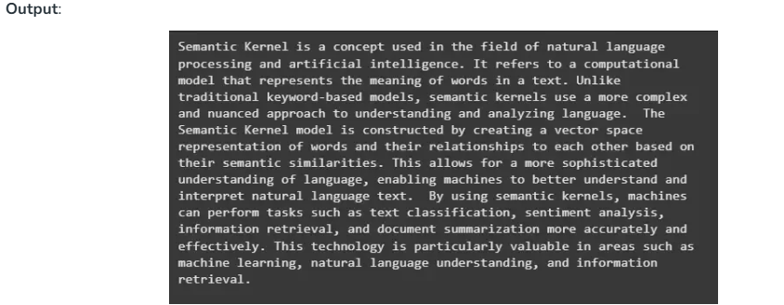

5. LangChain
LangChain is an open-source framework designed to streamline the development of applications powered by large language models (LLMs). It excels at chaining together modular components such as prompts, data loaders, memory and external tools enabling developers to build, customize and deploy context-aware AI workflows with ease.

Features:
- Tool Integration: Call external APIs, search engines and databases to augment LLM capabilities.
- Human-in-the-Loop: Design workflows for human review, approval or intervention where needed.
- Multi-Agent & Agentic Workflows: Support for creating agents that communicate, reason and act either independently or together.
- Integration with LLMs: Seamlessly connect to OpenAI, Anthropic, Hugging Face and other leading LLMs.
- Memory & Context: Maintain state and conversation history across interactions for personalized, multi-step experiences.
Use Case: An AI customer support agent uses LangChain to fetch FAQs from a database, answer user queries with an LLM, log interactions for future context and escalate unresolved issues to a human agent, all in a single automated workflow.

Code:
Let's see a code example to understand better,
- Loads OpenAI API key from Colab secrets
- Installs necessary Langchain packages
- Defines an LLM with GPT-4o-mini model at zero temperature
- Creates a prompt template asking for a fun fact about a topic
- Chains prompt generation, LLM call and string output parsing
- Invokes chain with topic "cats" to generate a fact
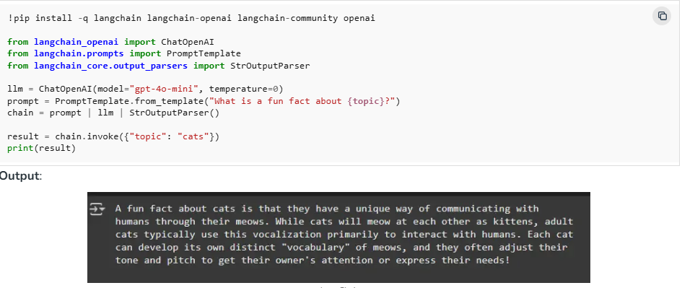

6. No-Code and Visual AI Agent Platforms
For business users, domain experts or fast prototyping, visual and no-code AI agent builders provide drag-and-drop simplicity.

1. n8n: Visual Agent Development Platform
- Workflow Automation Plus AI: n8n Enables users to construct AI workflows integrating 400+ apps like Notion, Stripe, Google Sheets, etc with LLMs and toolchains all via a graphical interface.
- Trigger-Based Flows: Agents can be initiated by webhook, chat message or custom event and use built-in nodes for data handling, communication and logic.
- Sales, Marketing, Support: Automate CRM updates, lead scoring, schedule communications or orchestrate sales pipelines without code.

2. Langflow: Modular Drag-and-Drop Framework
- Multi-Agent and RAG Support: Designed for visually constructing complex agentic workflows including collaborative multi-agent scenarios and Retrieval-Augmented Generation tasks.
- LLM and Vector Store Agnostic: Choose any mainstream or open-source model or vector DB and extend features as needed.
- Prototyping and Collaboration: Rapidly test, iterate and deploy flows and share, embed or serve flows via APIs for enterprise integration.

Choosing the Right Framework
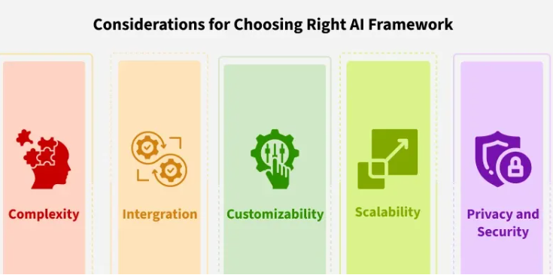

1. Complexity of Tasks:
- For multi-step, stateful processes that require keeping track of context or conversation history, LangGraph and CrewAI are strong choices.
- If our workflow is primarily LLM-powered and modular (e.g., question-answering, retrieval-augmented generation), LangChain is purpose-built for chaining prompts, tools and memory.
- AutoGen excels in dynamic multi-agent conversations where agents with different roles interact, debate or collaborate on complex problems.

2. Integration Needs:
- For no-code, visual workflow design and easy connectivity with business tools, Langflow and n8n stand out. These platforms let us quickly build and deploy integrations without writing code.
- If we need deep code-level integration with existing systems and APIs, Semantic Kernel is designed for embedding AI logic directly into applications using C#, Python or Java.

3. Customizability and Scalability:
- Semantic Kernel, LangGraph and AutoGen are all built for enterprise-scale extensibility, offering modular plugins, agent frameworks and support for advanced orchestration.
- CrewAI is particularly suited for collaborative multi-agent teams in specialized roles, ideal for automating business processes that benefit from teamwork.

4. Privacy & Data Security:
- Semantic Kernel and LangGraph are particularly well-suited for organizations requiring strict compliance (e.g., GDPR, HIPAA) due to their modularity and enterprise-grade features.
- AutoGen and CrewAI workflows should be designed with secure communication channels between agents and clear data retention policies.
- Langflow and n8n offer convenience, but always confirm that third-party integrations meet our security standards before connecting sensitive systems.

In recent years, Large Language Model (LLM) agents have emerged as a transformative force in artificial intelligence. Unlike traditional chatbots that rely on predefined responses, LLM agents possess the ability to reason, plan and execute tasks autonomously which making them valuable tools across various industries.
LLM agents are AI system that are powered by large language models (LLMs) and they extend the capabilities of traditional AI models by allowing for conversational interactions, task execution, reasoning and a degree of autonomy. These agents can perform variety of complex tasks autonomously based on instructions and prompts. These prompts define the agent's identity, goals, behavior and context, i.e., significantly influencing the response and actions of the agent.

Core Components of LLM Agents
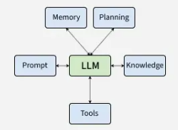
1. Agent Core/LLM Agent: The central processing unit that manages the overall logic and behavioral characteristics of the agent is the large language model itself. It interprets inputs, makes decisions and coordinates actions. The size and design of the model plays an important role in determining the agent's capabilities.
2. Memory Module: This component stores information about previous interactions and experiences. It includes both short-term memory, which handles ongoing tasks and long-term memory, which retains historical context. LLM agents typically utilize two types of memory:
- Short-term Memory: This is used to manage current conversations or tasks and help the agent track ongoing activities.
- Long-term Memory: This memory is linked to external databases and helps the agent retain a vast amount of data which allows them to refer back to past interactions for improving context and enhancing reliability for future tasks.
3. Planning Module: The planning module enables the agent to break down complex tasks into smaller manageable steps to plan actions accordingly and adjust its plans based on new information as it becomes available.
4. Knowledge: By integrating knowledge, LLM agents can generate more accurate, contextually aware responses and perform complex tasks. Knowledge can be specific to a domain or general world knowledge or any skill for task completion.
5. Tools: LLM agents often utilize external resources or APIs that the agent can use to perform specific tasks such as retrieving data, making calculations or interacting with other systems.
6. Prompt: Prompts encode essential information such as the agent's identity, expertise, goals and context. Different types of prompts help guide the agent's actions such as conversational prompts help establish an identity while task-oriented prompts clarify objectives and provide the necessary context to achieve a goal.

Working of an LLM Agent
An LLM agent works by using a combination of the core language model and external components to interpret inputs, generate responses and perform tasks on its own. Here is how it works:
- Input Processing: The agent receives an input from user which could be a question, command, or request.
- Task Identification: The agent processes the input to determine the task. This step involves understanding the nature of the query. It is a important step as it guides the agent's next steps.
- Reasoning and Action: The agent uses its trained language model to generate a response or take an action based on the input and its knowledge. It might also interact with external tools or APIs to perform more complex tasks, such as retrieving real-time data from the web or accessing a database.
- Output Generation: The agent generates the appropriate response or takes the necessary action which is then presented or passed to another system.
- Feedback Loop: The agent may learn from the output, especially if the response is evaluated or refined based on user feedback. This helps the agent improve its future performance and enhance its capabilities.
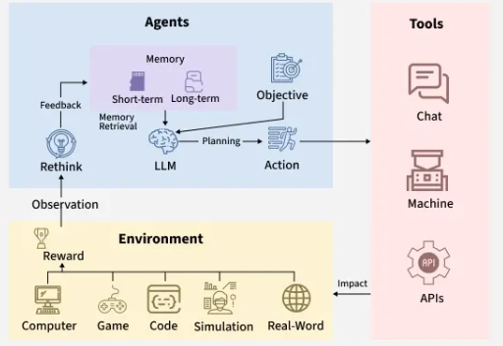

Types of LLM Agents
There are different types of LLM agents based on the kind of task or interaction they are designed for,
1. Web Agents: Web agents are LLM-based systems that are designed to navigate the web for information and executing tasks on the internet. They gather real-time data, interact with websites and perform tasks that require dynamic and real-time web interactions. Example: MIND2Web, WebAgent.
Key features:
- Web agents use LLMs to understand and generate web actions.
- They are capable of navigating websites, extracting data and interacting with web-based services.
- They integrate well with frameworks like LangChain or ChatGPT to enhance their capabilities.
2. Tool Agents: Tool agents are LLM-based systems that enhance the capabilities of LLMs by integrating with external tools, APIs, or services. They can use these external resources to accomplish tasks and extend their functionality. Example: Gorilla, ToolLLM Framework.
Key features:
- Tool agents are equipped with external tools and APIs for performing complex operations.
- They adjust in real-time by utilizing external systems such as databases, software tools and APIs.
- They can automate processes and interact with external services.
3. Hybrid Agents: Hybrid agents combine the functionalities of both web agents and tool agents which allows them to perform complex tasks that involve both web navigation and the use of external tools. These agents can gather real-time data from the web and then use that information to interact with APIs, databases, or other systems to execute more advanced tasks. Example: AutoGPT, CensusGPT.
Key features:
- Hybrid agents can integrate both web navigation and external tools in a single framework.
- They are capable of performing end-to-end tasks autonomously.
4. Task-Oriented Agents: Task-oriented agents are designed to perform specific tasks based on clear objectives. These agents focus on goal achievement and often include a well-defined set of operations that they perform sequentially to complete the task. Example: BabyAGI, AutoGPT.
Key features:
- Task-oriented agents are highly focused on achieving defined goals.
- They use predefined templates and structured prompts to perform tasks.
- They are capable of executing multi-step procedures and interacting with multiple tools.
5. Multi-Agent Systems: Multi-agent systems consist of multiple autonomous agents working together to achieve a common goal. These agents communicate, collaborate and divide tasks to optimize performance and solve complex problems.
Key features:
- Multi-agent systems collaborate easily to complete tasks.
- They divide tasks to utilize specialized skills.
- Each agent act independently but coordinates when needed.

Applications of LLM Agents
LLM agents are used across various industries due to their abilities to process large amounts of data, understand context and to perform complex tasks. Lets see some key areas where LLM agents are contributing,
- Customer Support: LLM agents are widely used in customer support systems to answer customer queries, resolve issues, provide personalized recommendations. They interact in natural language which provides a conversational interface that improves the user experience. Chatbots and automated ticketing systems are examples of customer support LLM model.
- Healthcare Assistance: LLM agents assist doctors, patients, healthcare professionals by providing medical information based on the input and historical data. Medical Chatbots and Clinical Decision Support Systems (CDSS) are some healthcare assistant LLM models.
- Finance and Investment: LLM agents help to analyze market trends, provide financial advices and assistance in decision-making processes which maybe related to investments, portfolio management and financial planning. Robo-Advisors and Automated Financial Reporting are some of Finance LLM agents.
- Education: LLM agents are being used as personalized tutors which help the students with their studies. They can provide explanations, answering questions and by offering feedback on assignments. Virtual Tutors and Automated Grading Systems are educational LLM agents.
- Human Resources (HR) and Recruitment: LLM agents assist HR departments in automating recruitments, employee training and performance management. They can analyze resumes, conduct initial interviews and also help with onboarding processes. Resume Screening and Employee Assistance are LLM agents which are useful in the HR management field.

Advantages of LLM Agents
LLM agents have numerous benefits which makes them valuable tools across various industries. Lets see a few of them,
- Automation and efficiency: They automate repetitive tasks which saves time and improves productivity.
- 24/7 Availability: LLM agents are available anytime which offers a constant service.
- Scalability: LLM agents can handle many tasks simultaneously without performance degradation.
- Consistency: They provide uniform and accurate responses each time.

Challenges faced by LLM Agents
Few challenges faced by LLM agents are mentioned below,
- Bias and Fairness: LLMs can inherit biases from training data which may lead to biased outputs.
- Data Privacy and Security: The agents handling sensitive data could risk privacy breaches if they are not secured.
- Resource Intensity: LLMs require significant amount of computational power which may be costly and energy-consuming.
- Handling Ambiguity: LLMs may provide irrelevant or inaccurate responses when inputs are vague.
Agentic AI systems offer a new way of using artificial intelligence allowing them to act on their own and pursue goals in changing environments. Unlike traditional AI which depends on human input, agentic AI can observe, reason, learn and make decisions independently without needing specific instructions.
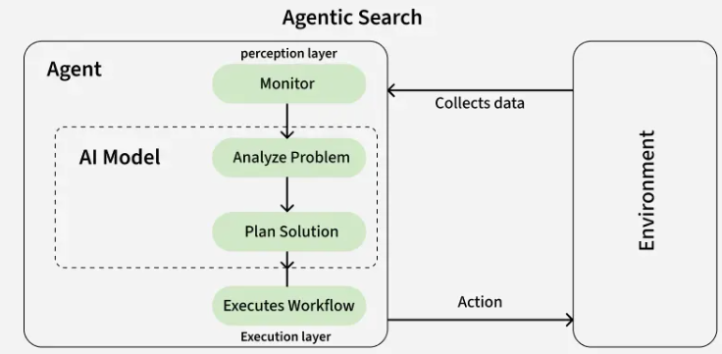

Types of Agentic Architectures
There are several types of agentic architectures each with its own strengths and weaknesses, suitable for different tasks and environments. Some common types include:
1. Single-agent architecture: A single AI system that functions independently, making decisions and taking actions without the involvement of other agents.
2. Multi-agent architecture: This architecture involves multiple AI systems interacting with each other, collaborating and coordinating their actions to achieve common goals. Its sub types are:
- Vertical architecture: This approach involves agentic AI systems organized in a hierarchical structure with higher-level agents overseeing and guiding the actions of lower-level agents.
- Horizontal architecture: This involves agentic AI systems operating on the same level without any hierarchical structure, communicating and coordinating their actions as needed.
- Hybrid architecture: This involves a combination of different agentic architecture types and using the strengths of each to achieve optimal performance in complex environments.

Components of Single Agentic AI Architecture
The architecture of an agentic AI system is composed of several key components that work together to ensure it operates independently and effectively. These components enable the system to make decisions, adapt to new information and learn from past experiences.
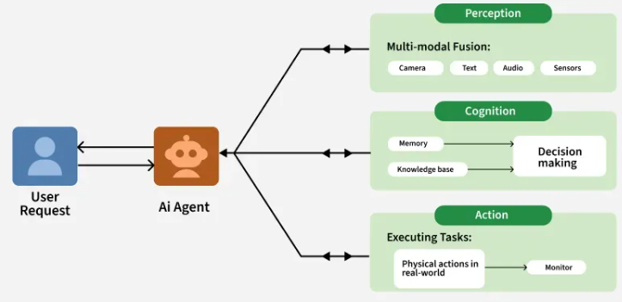

1. Perception
The way by which the agent collects information from its surroundings and using inputs like images, sound, text or sensor data is perception. Systems use sensors, data streams and external databases to understand their environment and recognize changes or events that need a response.
- Sensors: These may include cameras, microphones, motion detectors or specialized sensors designed to monitor specific aspects of the environment like temperature, location, etc.
- Data Integration: The AI system integrates data from multiple sources allowing for a comprehensive understanding of the situation. This can involve data from IoT devices, external APIs and historical datasets.

2. Cognitive Layer
After understanding its environment agent must analyze the data and decide the best action. This process involves assessing the current situation, considering potential outcomes and selecting the best action based on predefined goals or objectives.
Agentic AI uses techniques such as:
- Rule-Based Systems: Simple systems that follow predefined rules to make decisions.
- Machine Learning Models: More advanced systems that use statistical techniques to learn patterns from data and make predictions.
- Reinforcement Learning: Agentic AI systems often use reinforcement learning where they learn through trial and error by receiving feedback i.e rewards or penalties based on their actions.

3. Action and Execution
The action component executes the decisions made by the agent. Once the agent processes the data and chooses an action, it takes action in the environment. This could involve sending commands to physical systems like a robotic arm or self-driving car and then handling data or communicating it with other systems.
- Robotics: In physical environments it can control robotic systems to perform tasks such as assembly, navigation and interaction with humans.
- Software Automation: In virtual environments it can control software systems to automate processes such as decision-making in business operations, customer service chatbots or IT systems management.

4. Learning and Adaptation
The systems need to adapt and get better over time by learning from past experiences. This enables them to handle new situations that may not have been specifically programmed. Learning mechanisms in agentic AI can be:
- Supervised Learning: Where the agent is trained on labeled data to make predictions or classifications.
- Unsupervised Learning: Where it identifies patterns in unlabeled data without predefined categories.
- Reinforcement Learning: It learns through trial and error, improving its decision-making over time by receiving rewards or penalties based on its actions.
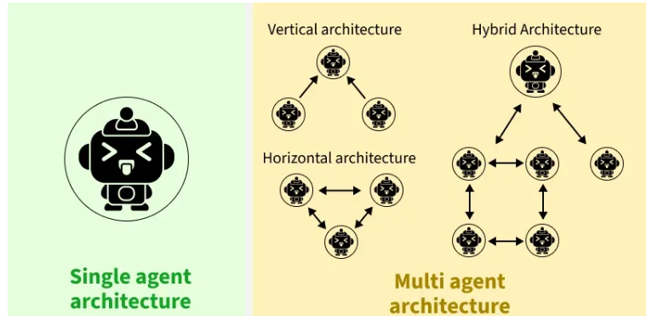
Agents divide a large problem into smaller tasks, collaborate to solve them and adapt their roles as tasks evolve for flexibility and fast response. Each agent may use unique methods, one might employ natural language processing (NLP), another computer vision, others use retrieval augmented generation (RAG) to pull external data.
Multi agent architecture can be further divided into:

1. Vertical AI Architecture
In a vertical architecture, a leader agent oversees subtasks and decisions, with agents reporting back for centralized control. Hierarchical AI agents know their role and report to or oversee other agents accordingly.
Key features:
- Hierarchy: Roles are clearly defined.
- Centralized communication: Agents report to the leader.
Strengths:
- Task efficiency: Ideal for sequential workflows.
- Clear accountability: Leader aligns objective.
Weaknesses:
- Bottlenecks: Leader reliance can slow progress.
- Single point of failure: Vulnerable to leader failure leading to whole system failure.
Use cases:
- Workflow automation: Multistep approvals.
- Document generation: Sections overseen by a leader.

2. Horizontal AI Architecture
Horizontal AI Architecture uses peer collaboration model in which agents work as equals in a decentralized system, collaborating freely to solve tasks.
Key Features:
- Distributed collaboration: All agents share resources and ideas.
- Decentralized decisions: Group-driven decision-making for collaborative autonomy.
Strengths:
- Dynamic problem solving: Fosters innovation.
- Parallel processing: Agents work on tasks simultaneously.
Weaknesses:
- Coordination challenges: Mismanagement can cause inefficiencies.
- Slower decisions: Too much deliberation.
Best use cases:
- Brainstorming: Generating diverse ideas.
- Complex problem solving: Tackling interdisciplinary challenges.

3. Hybrid AI Architecture
Combines structured leadership with collaborative flexibility. Here leadership shifts based on task requirements.
Key features:
- Dynamic leadership: Leadership adapts to the phase of the task.
- Collaborative leadership: Leaders engage their peers openly.
Strengths:
- Versatility: Combines strengths of both models.
- Adaptability: Handles tasks requiring both structure and creativity.
Weaknesses:
- Complexity: Balancing leadership roles and collaboration requires robust mechanisms.
- Resource management: More demanding.
Best use cases:
- Versatile tasks: Strategic planning or team projects.
- Dynamic processes: Balancing structured and creative demands.

Agentic Framework
Agentic frameworks refer to design architectures or models that define how agents (whether artificial or natural) can perform tasks, make decisions and interact with their environment in an autonomous, intelligent manner. These frameworks provide the structure and guidelines for how agents operate, reason and adapt in various settings.
- Reactive Architectures: It links immediate environmental input to direct responses. These agents operate on instinct, acting solely on current stimuli without using memory or planning. They are unable to learn from the past or anticipate future events.
- Deliberative Architectures: It enables agents to act by reasoning, strategizing and building internal representations of the world. Unlike reactive systems, these agents assess their surroundings, consider possible outcomes and make decisions after thoughtful analysis.
- Cognitive Architectures: It simulates human-like intelligence. They combine perception, reasoning, learning and decision-making abilities, allowing agents to handle complex tasks by thinking and adapting much like people do.

What You're Aiming For
Objectives
- Understand how an AI agent can use external tools (e.g., calculator, search).
- Implement fallback logic when a tool fails or is not appropriate.
- Learn how agents decide between tool use and direct reasoning.

Skills Acquired
- Defining and integrating tools into an agent workflow.
- Handling tool errors with fallback to LLM reasoning.
Designing robust agent responses for real-world use cases.

Instructions

- Define at least 2 tools (e.g., Calculator, Search).
- Create an agent that selects the right tool based on user input.
- Implement fallback logic:
  - If a tool fails (error, timeout, irrelevant), the agent answers directly using the LLM.
  - Log whether the answer came from a tool or fallback.
- Test with queries that:
  - Require tools (e.g., “What is sqrt(144) + 5?”)
  - Fail a tool (e.g., simulate search error) → fallback
  - Can be answered directly (e.g., “Who are you?”).

Example
- Input: “What is 12 * 8?”
  - Agent uses Calculator → Answer: 96
- Input: “Search 404 test”
  - Tool fails → Fallback to LLM → Answer generated
- Input: “Tell me something about Tunisia”
  - Agent uses Search or directly answers with LLM

Check Your Work
- Did the agent successfully use tools when possible?
- Did it fallback correctly when tools failed?
- Did you log or indicate the route (tool vs fallback)?

Skill Check

- Can you explain why fallback logic is essential for real-world AI agents?
- Can you add a confidence-based fallback (e.g., if tool output is too short, fallback to LLM)?

